runTest() - method called from ObserverTest class.

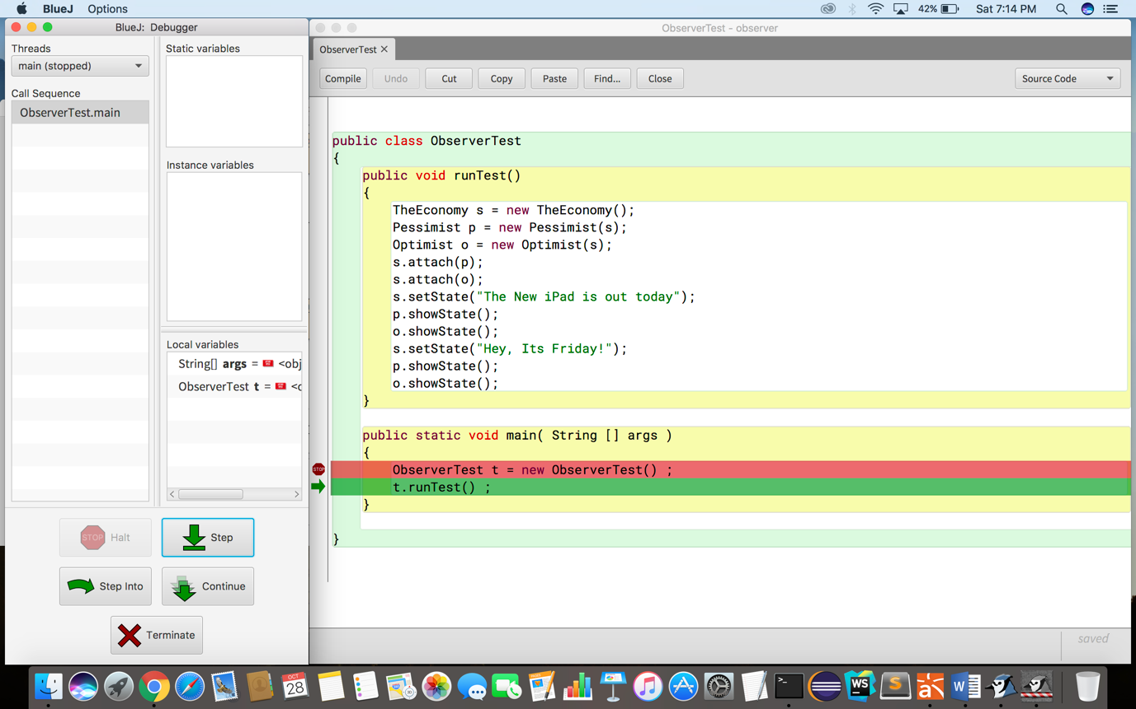

s.attach(p) - Calling the method from Economy with the parameter of Pessimist object which will add Pessimist object to its arraylist.

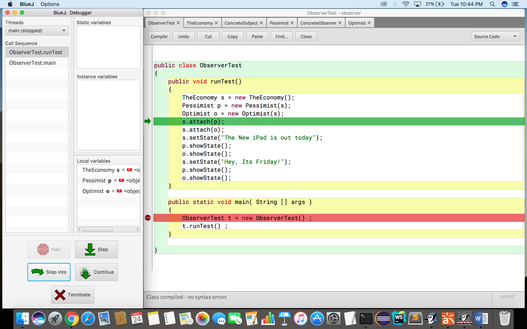

observers.add(p) - In attach method, adding the Pessimist object.

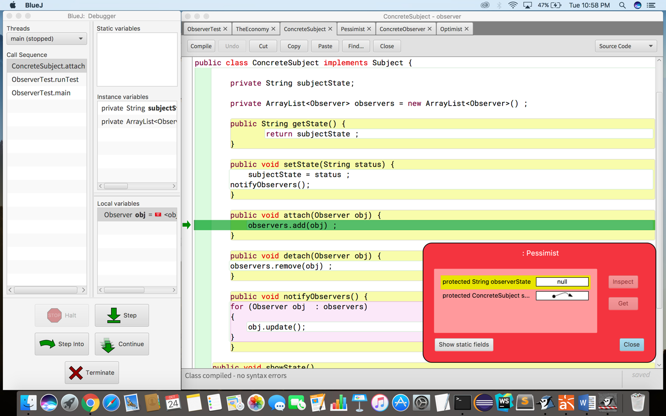

s.attach(o) - Calling the method from Economy with the parameter of Optimist object and adding Optimist object to its arraylist.

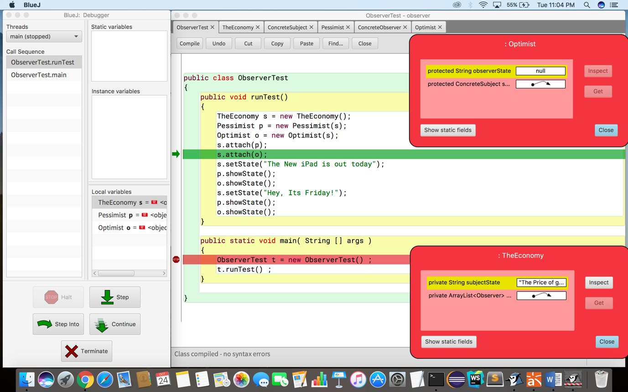

observers.add(o) - In attach method, adding the Optimist object.

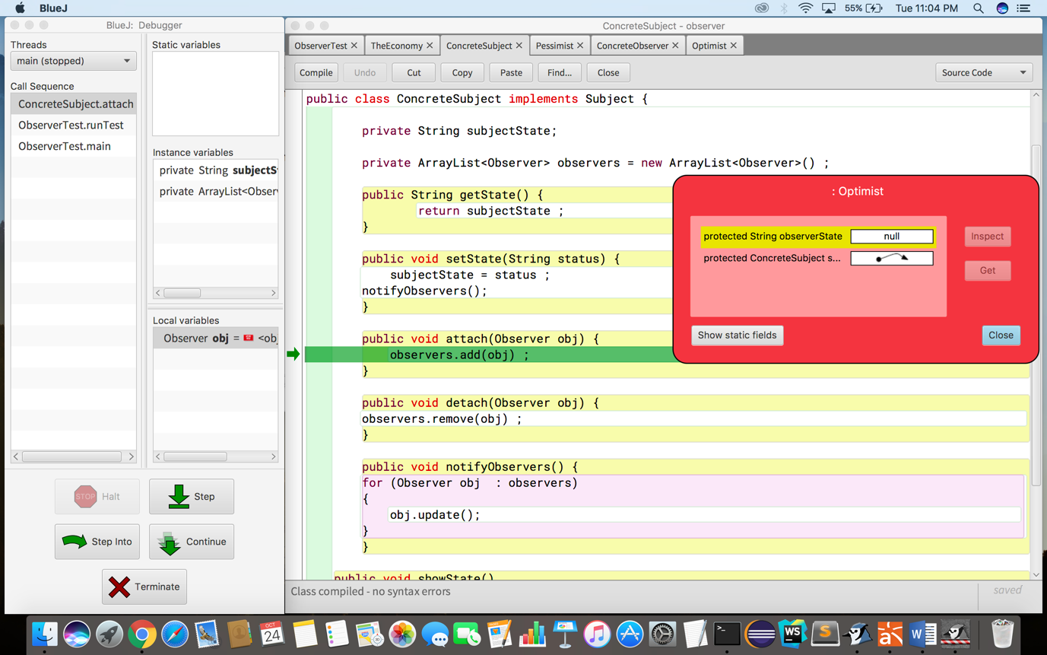

s.setState() – Setting the state of Economy class with “The new Ipad is out today”.

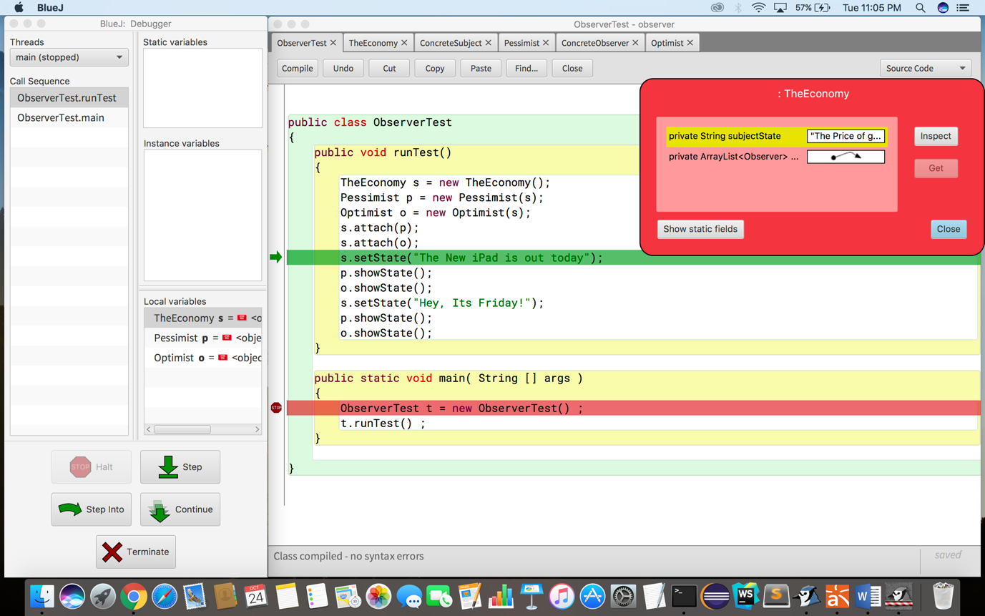

notifyObservers() – After setting the state of Economy class, notifying the Observers to update their state.

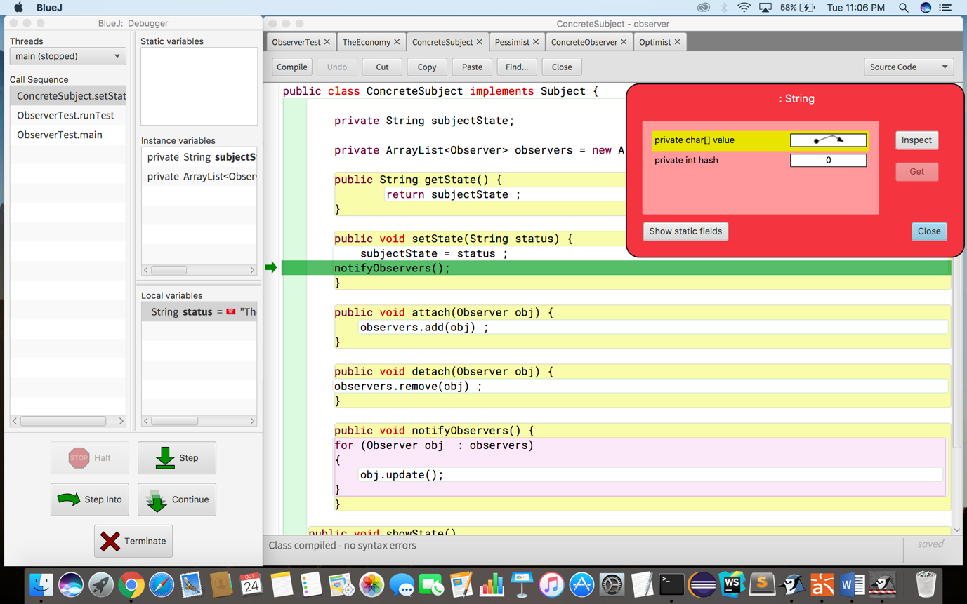

obj.update - Updating the state of Pessimist observer class with the new state.

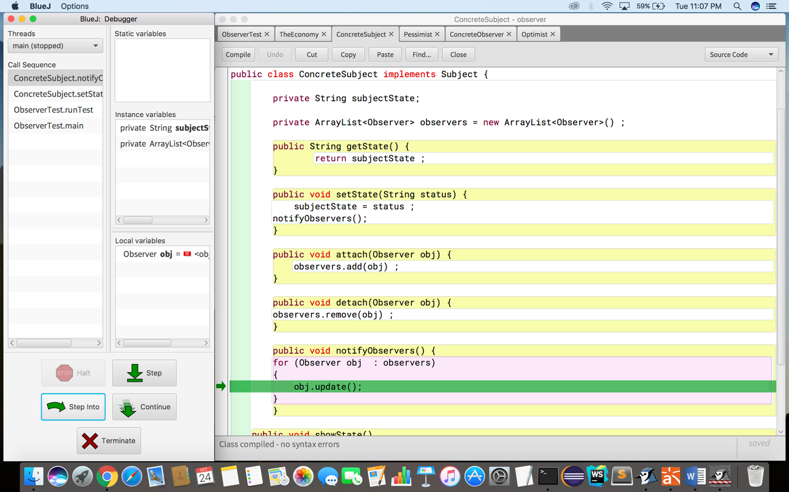

Calling update method of Pessimist.

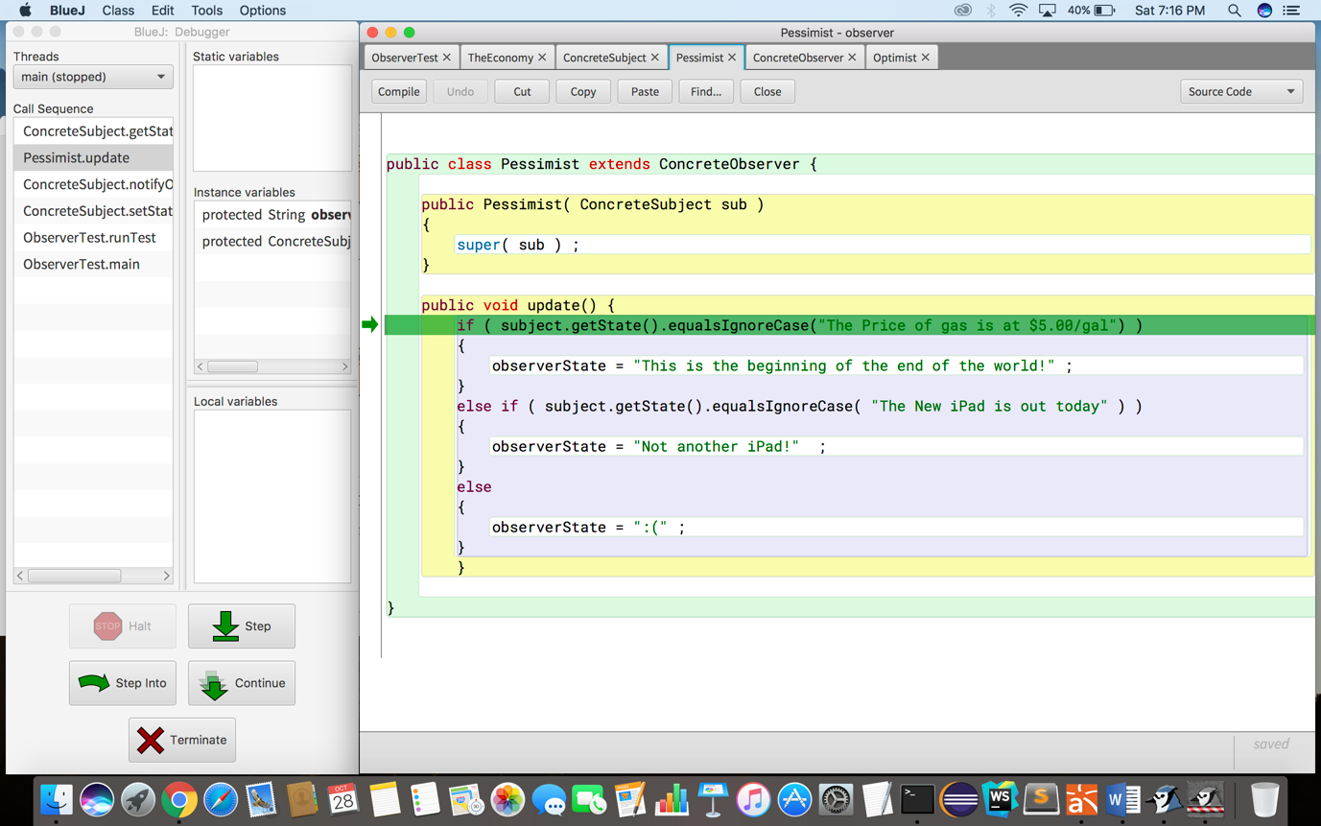

Returning the state.

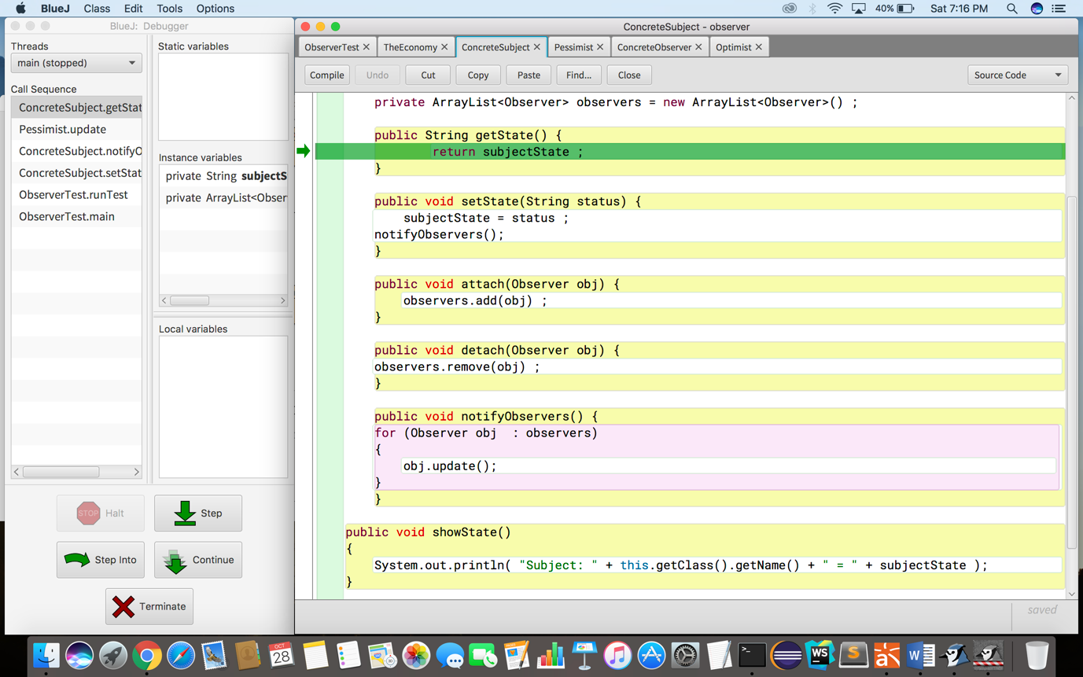

Update method of Pessimist called to get the current state.

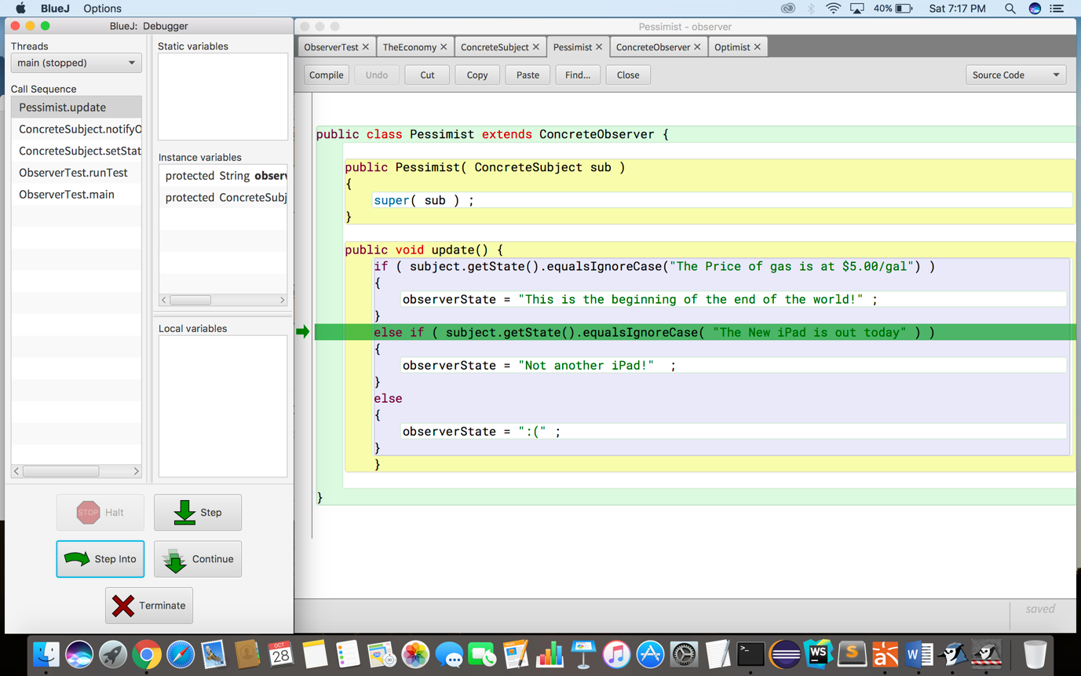

Returning the state.



Setting the state of the Pessimist as “Not another Ipad” based on the state of Economy class which is right now the “The new Ipad is out today”.

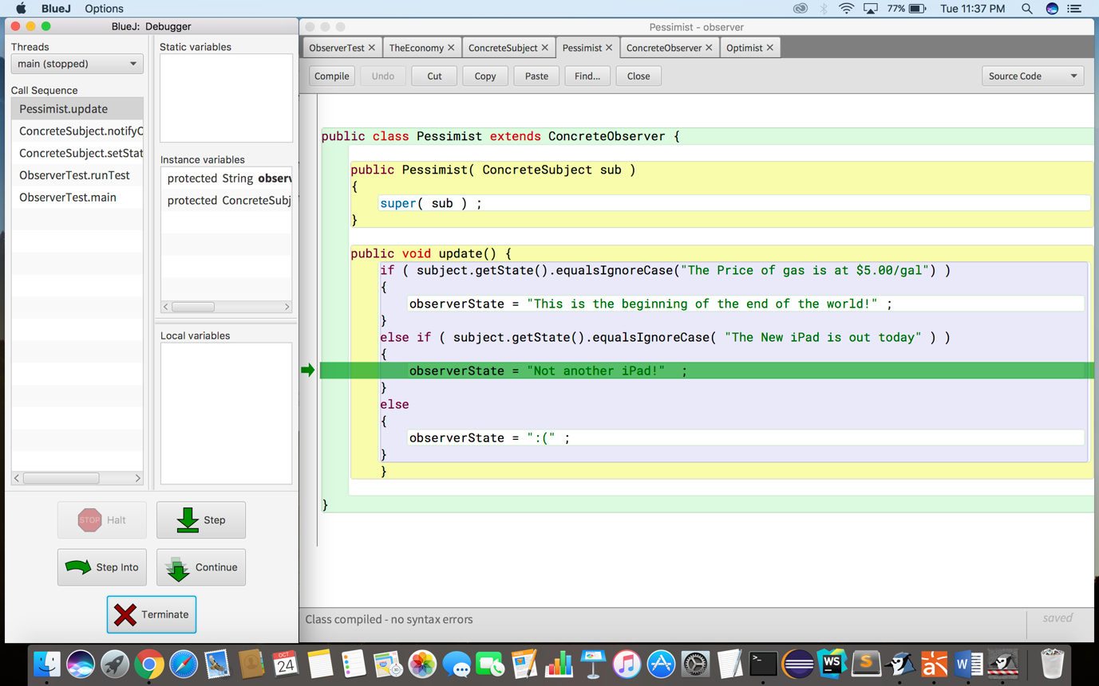

Calling update method of Optimist Observer.

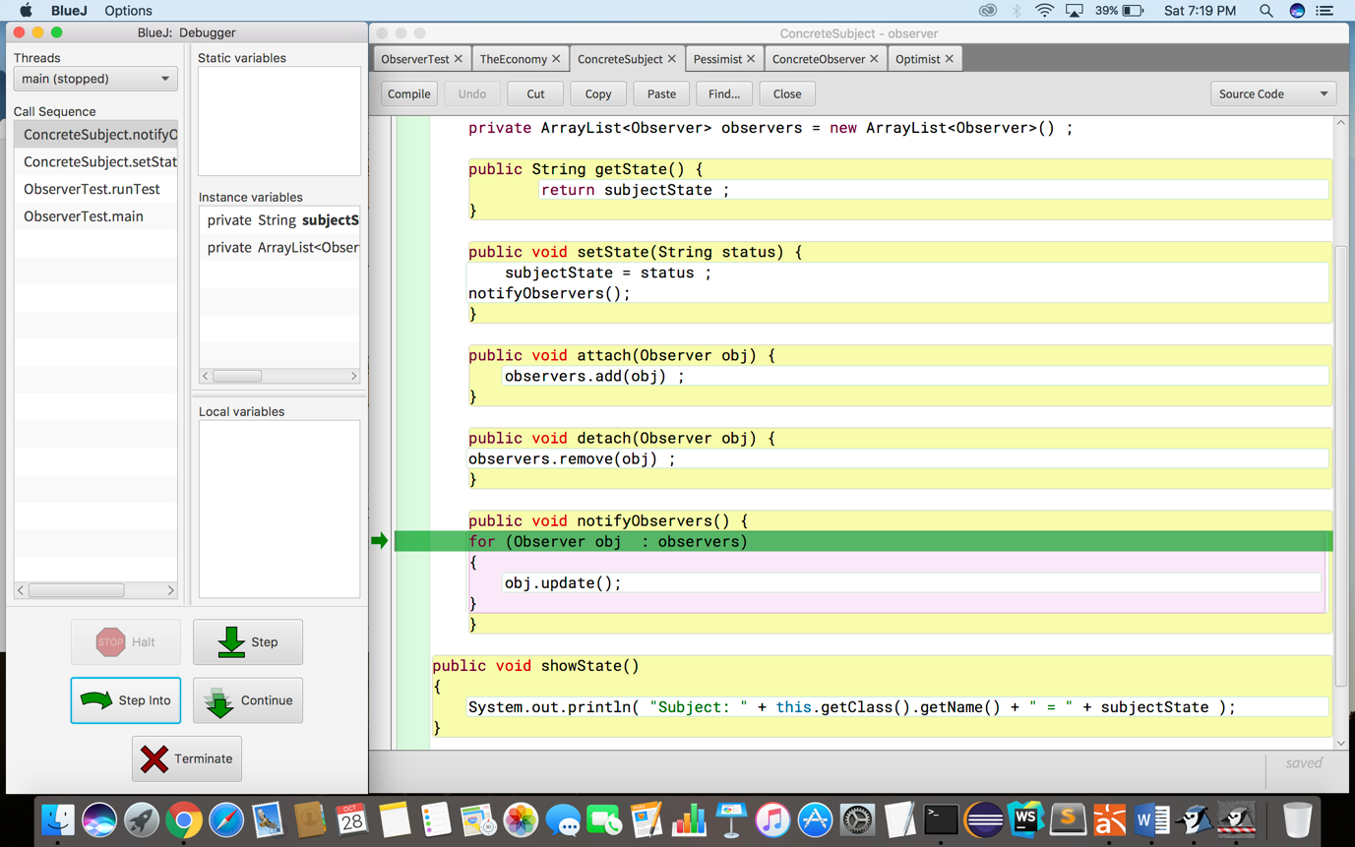

Update method of Optimist called.

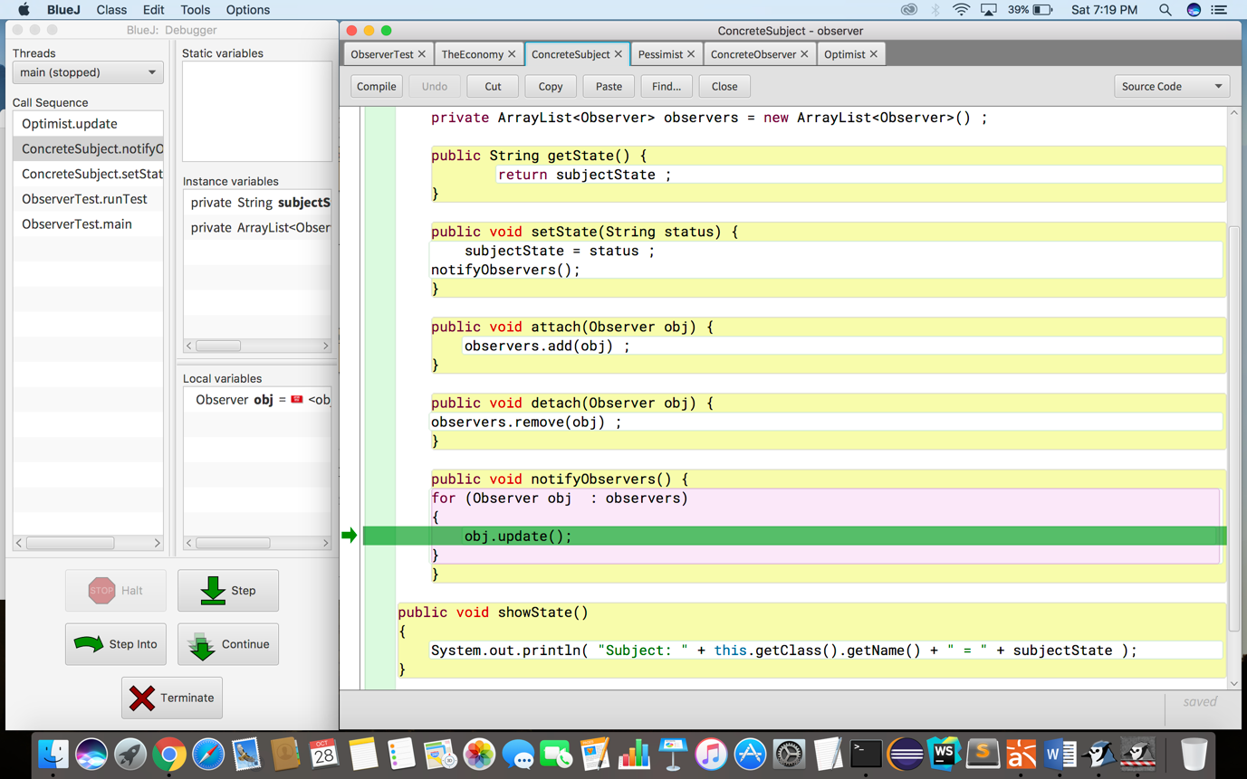

Update method calls getState of Optimist to get the current state.

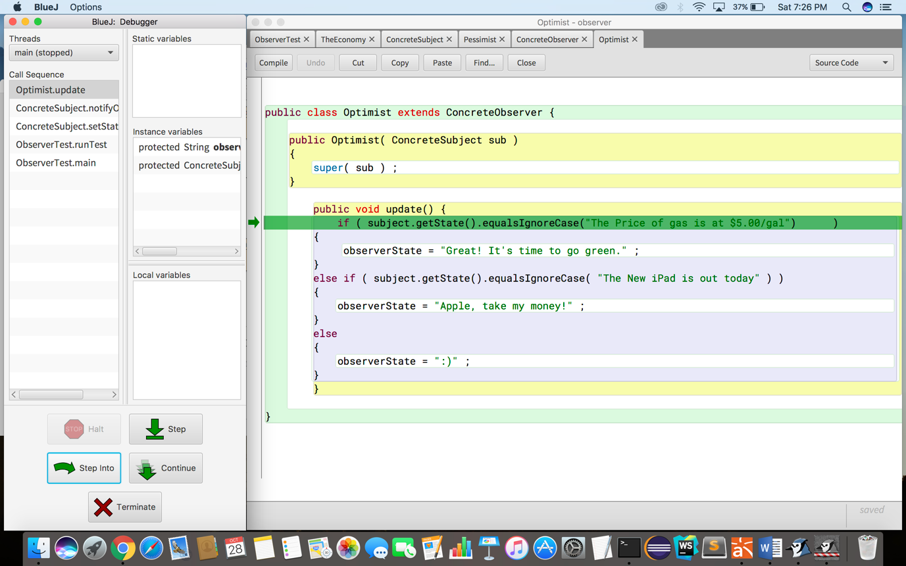

Returning current state.



Update method calls getState of Optimist to get the current state.

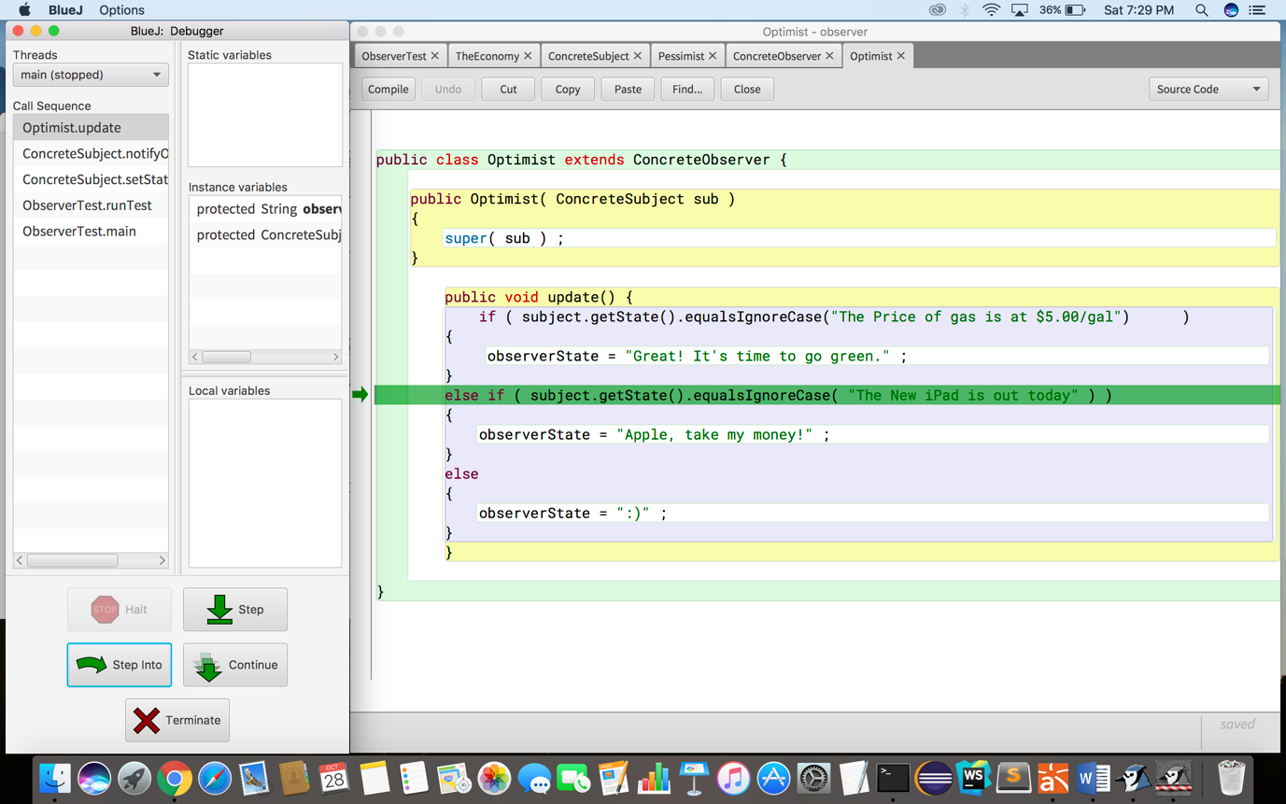

Returning the current state.



Setting the state.

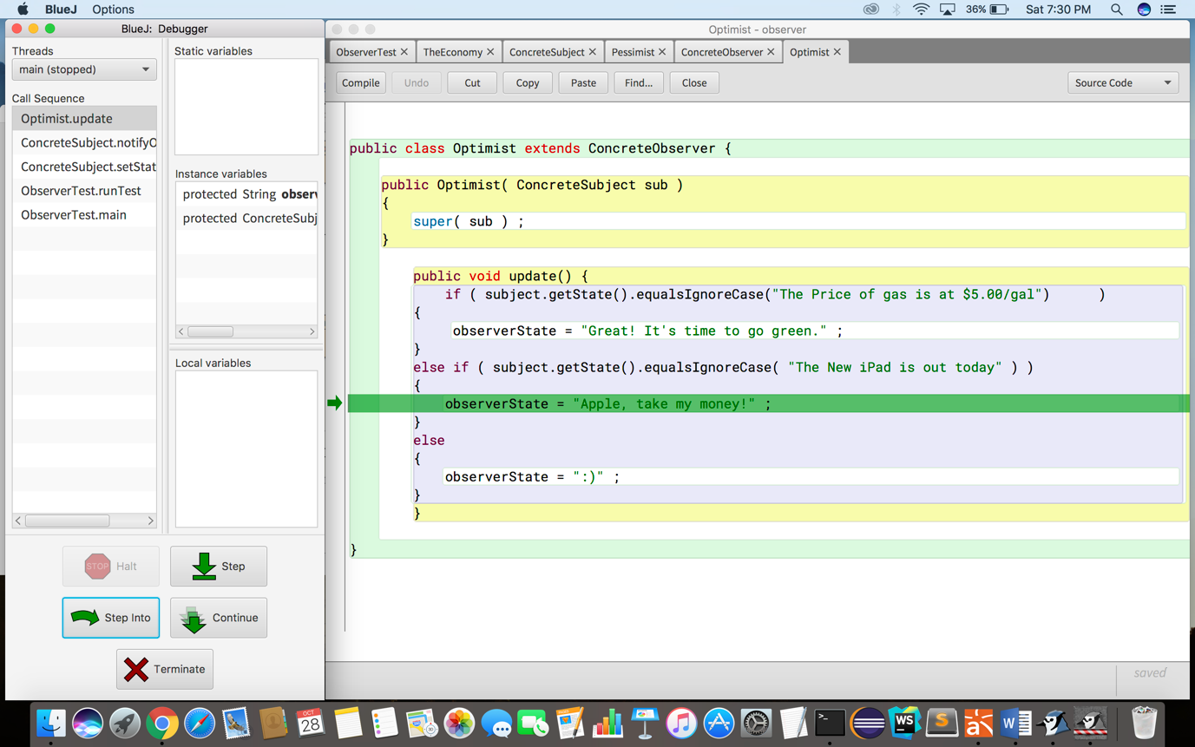

p.showState() – Get the state of Pessimist class.

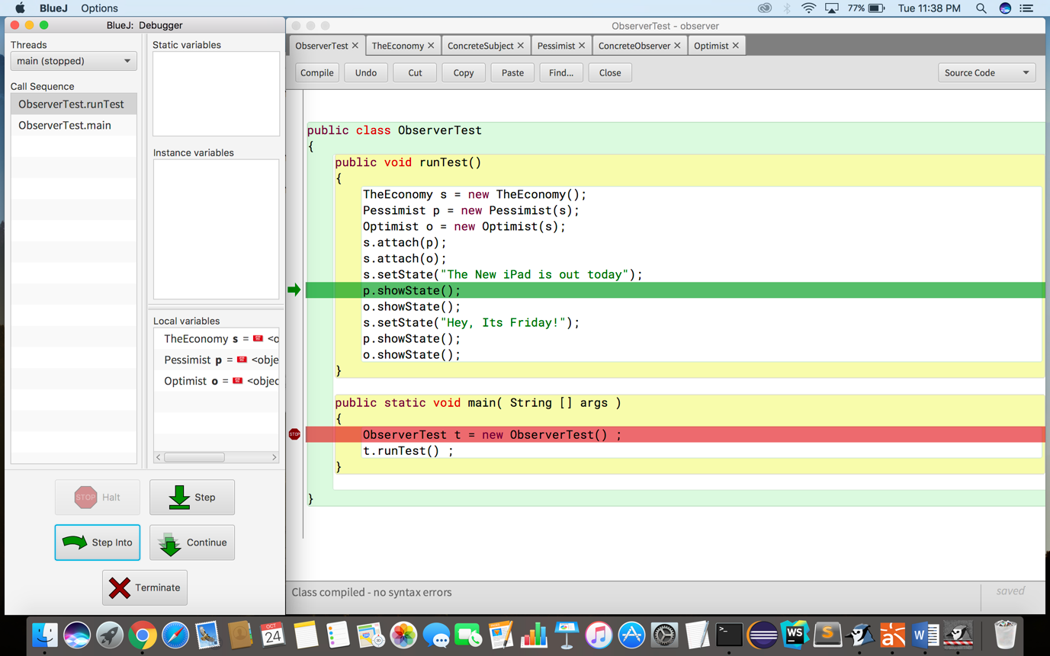

Inside showState method from where state of is printed.

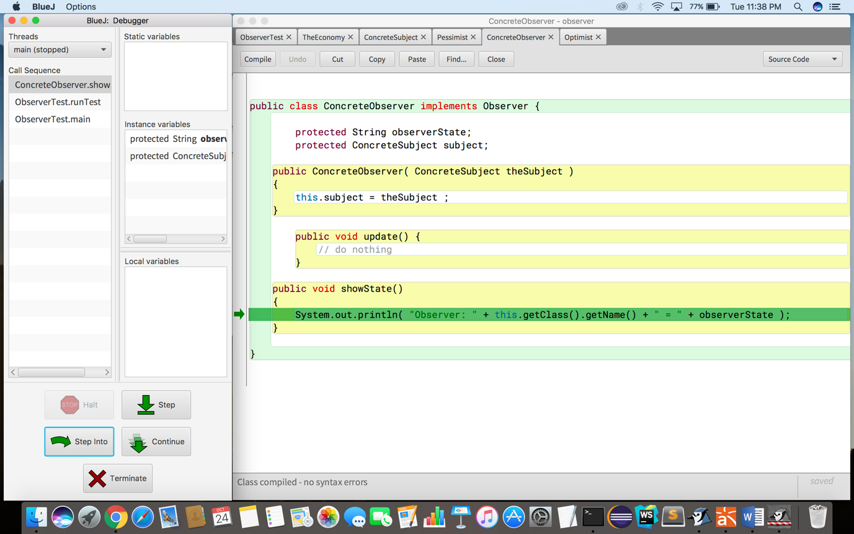

o.showState() – Getting the state of Optimist object.

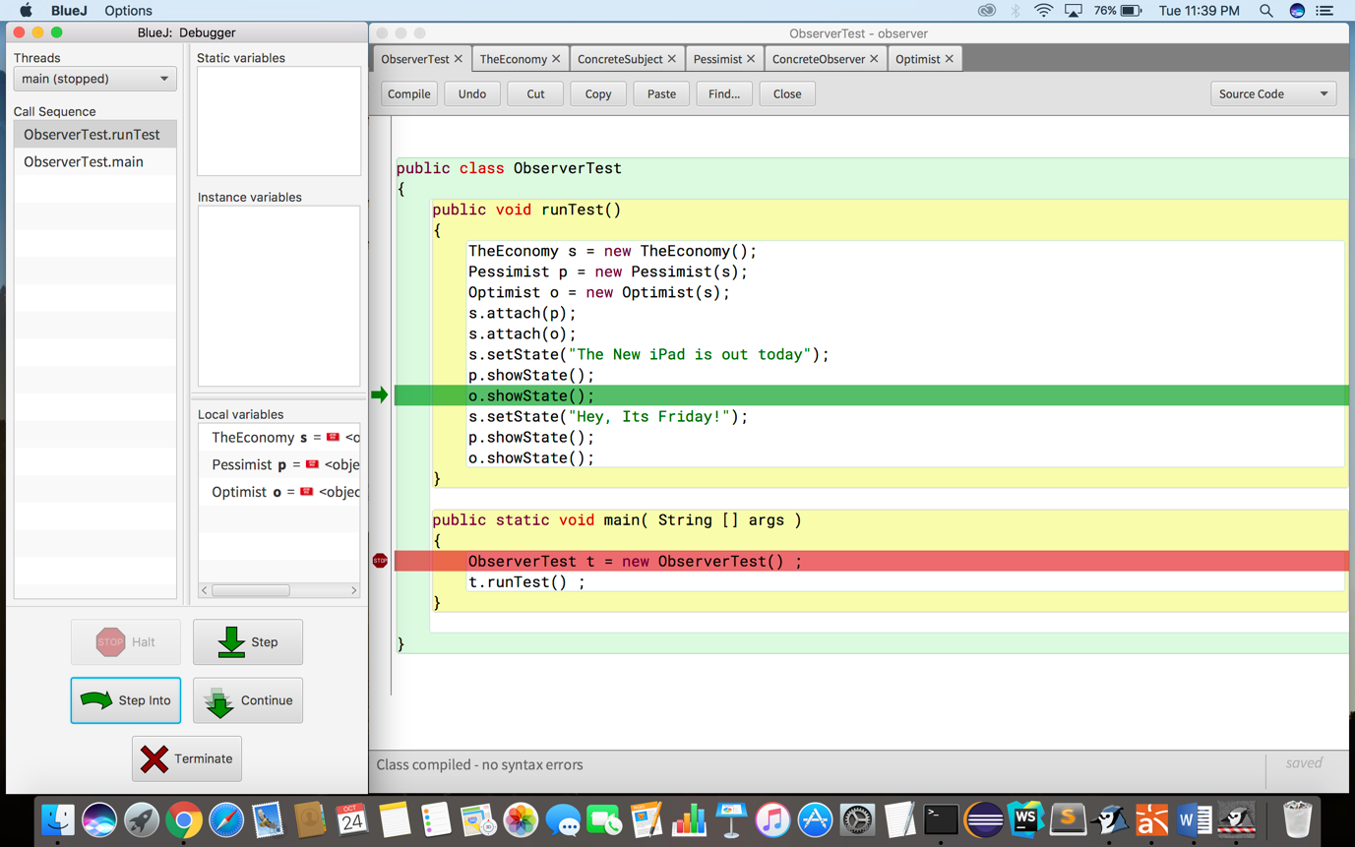

Inside showState() – Displaying the state of the Optimist class.

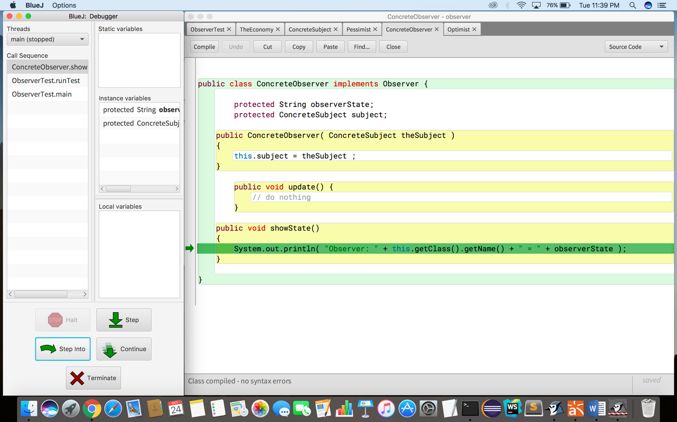

s.setState() – sets the new state for The Economy class.

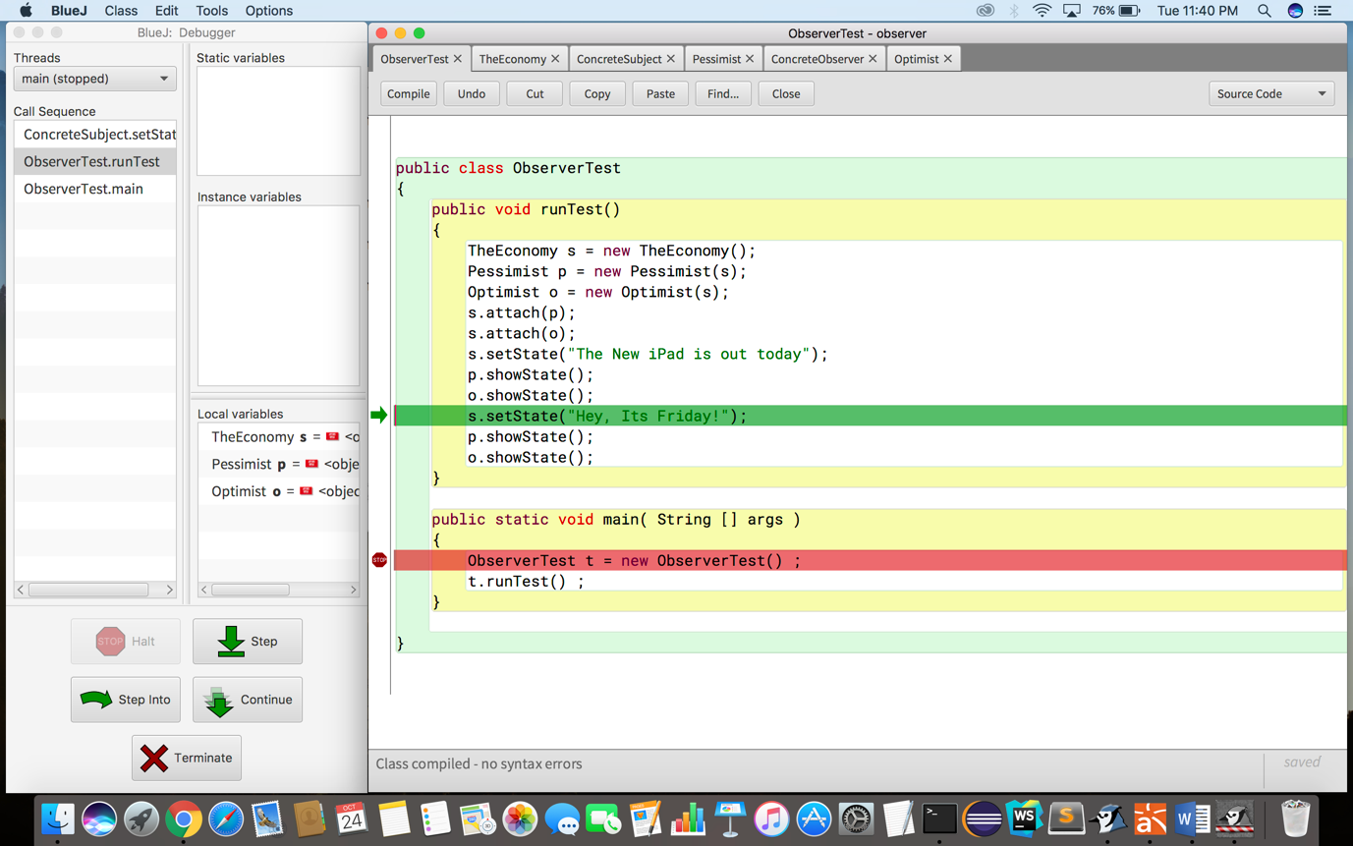

notifyObservers() – notifies all the observers about the updated state.

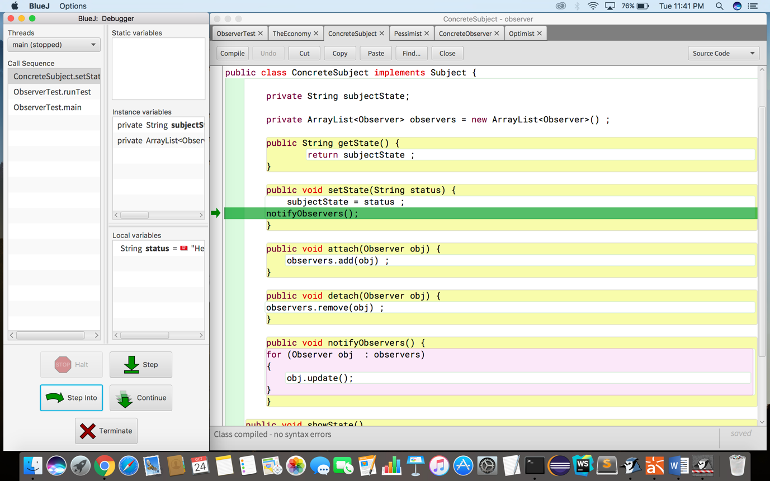

notifyObservers calls method of each Observer.



obj.update() – After notifying, updates the state of pessimist observer.

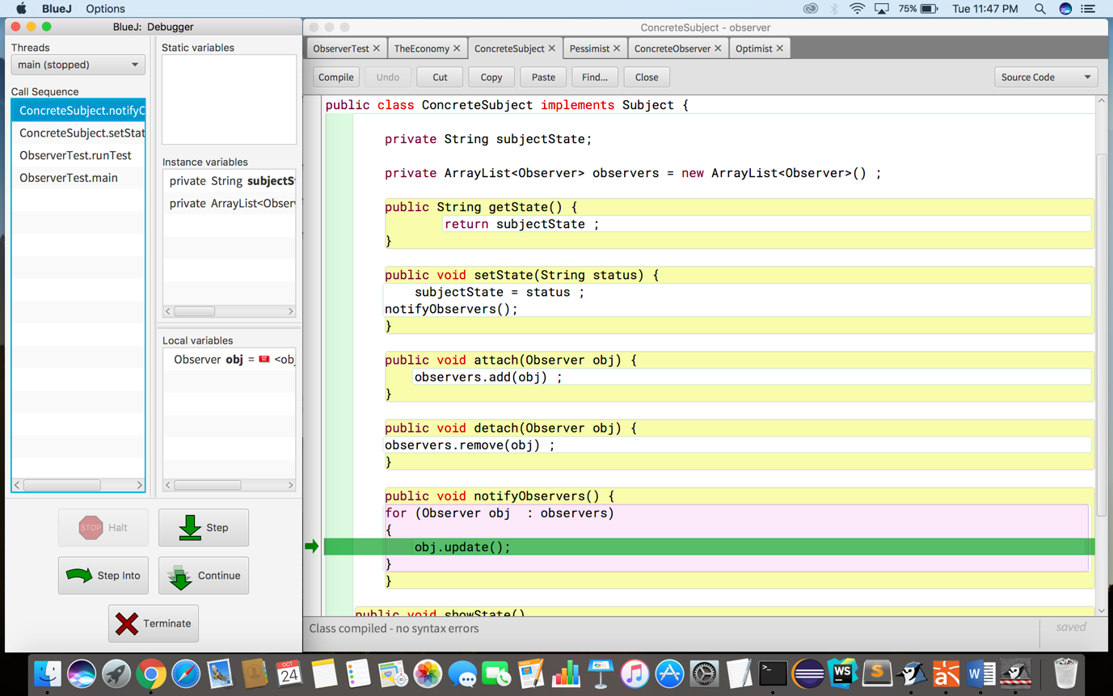

Update method calls getState to get the current state of observer.



Returning the state.



Update method calls getState to get the current state of Observer.



Returning the state.



Setting the observer state as “☹”.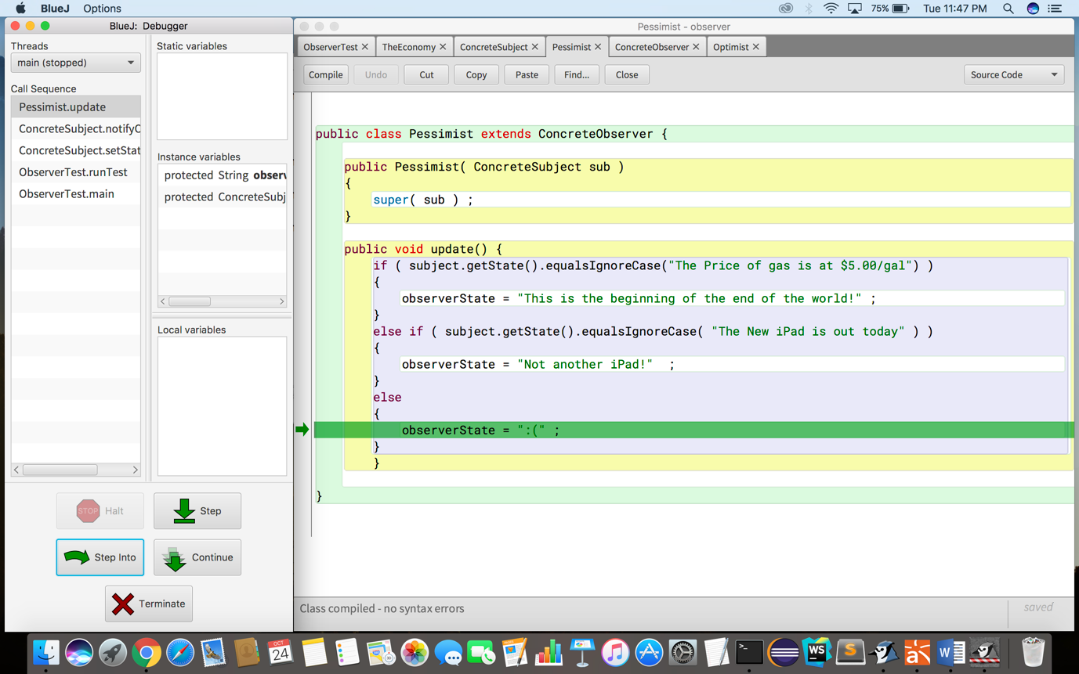

Calling the update method of each Observer.



Calling update method of observer to change the state of observers.



Update method called of the observer.



Returning the state.



Checking the state of observer.



Returning the state.



Setting the observer state.

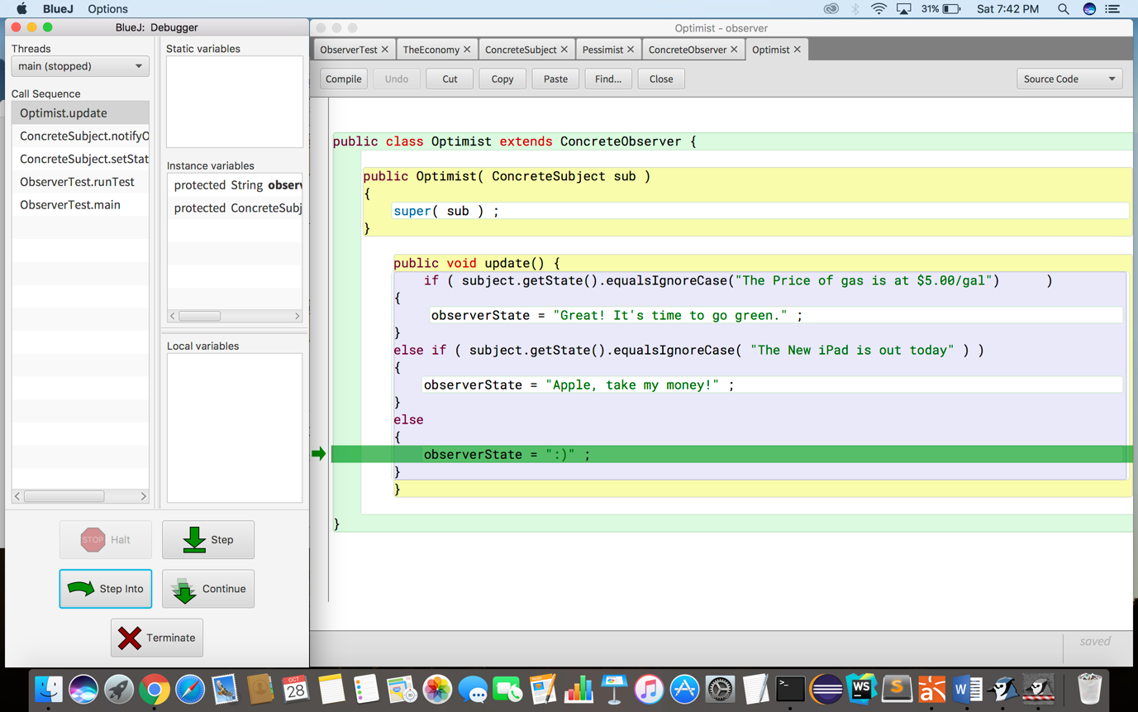

p.showState() – getting the state of Pessimist object.

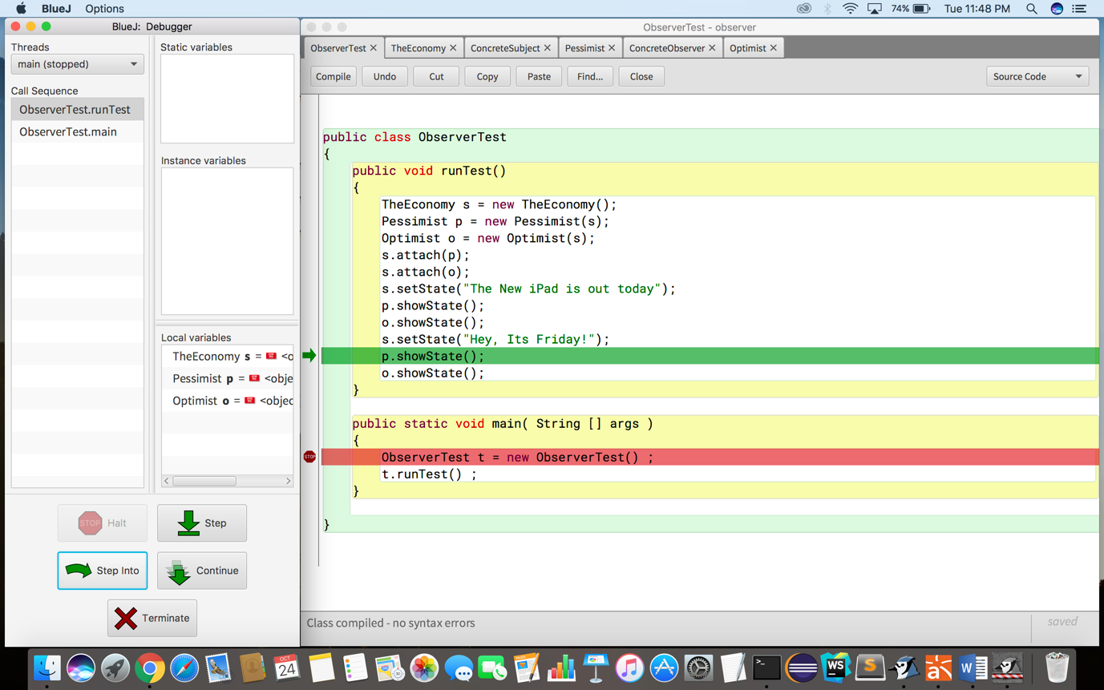

Inside showstate() – Displaying the state of the Pessimist class.

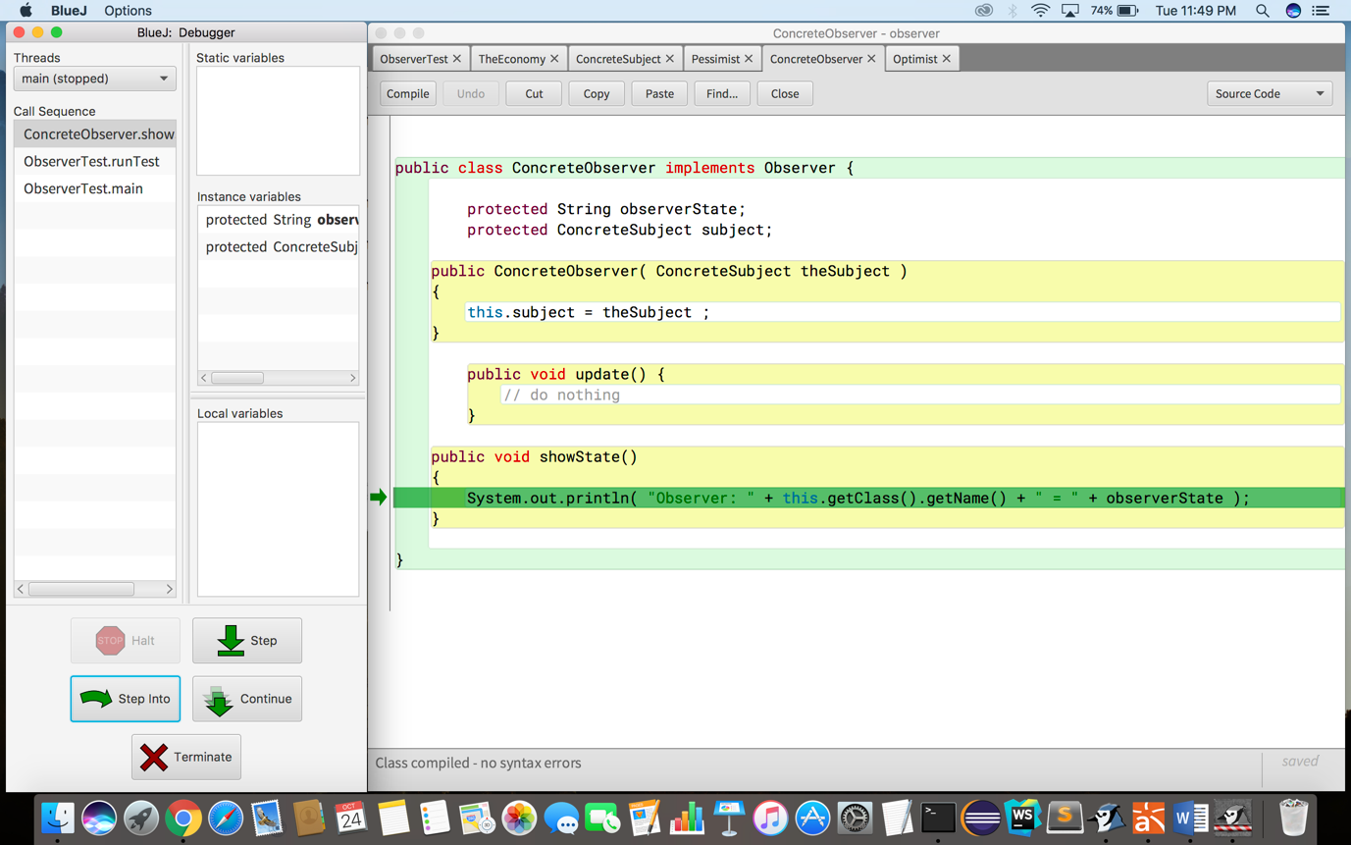

o.showState() – Getting the state of the Optimist class.

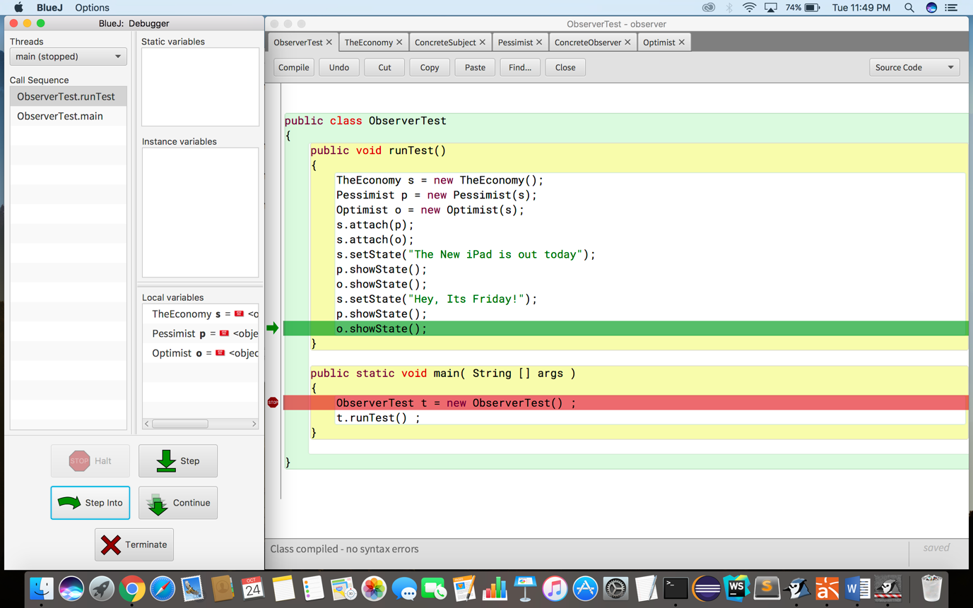

Inside showState() – Displaying the state of the optimist class.

